OWNERS MANUAL

MODEL:
STREET VENDOR 4
Professional Popcorn Machine

PART NUMBER:
11040
115 volts, 60 hz
 WARNING: Handling the cord on this product may expose you to lead, a chemical known to the State Of California to cause cancer and birth defects or other reproductive harm. WASH HANDS AFTER HANDLING.

WARNING ELECTRICAL SHOCK HAZARD.

FAILURE TO FOLLOW THESE INSTRUCTIONS COULD RESULT IN SERIOUS INJURY OR DEATH.
Electrical ground is required on this appliance.
- Do not modify the power supply cord plug. If it does not fit the outlet, have a proper outlet installed by a qualified electrician.
- Do not use an extension cord with this appliance.
- Check with a qualified electrician if you are in doubt as to whether the appliance is properly grounded.

SAFETY INSTRUCTIONS
1. Plug electrical cord into a certified electrical outlet with a corresponding voltage rating as listed on the machine model labels.
2. Always unplug the electric cord when appliance is not in use and before cleaning, adjusting or maintaining this steamer. Do not operate with a damaged cord or plug or after the machine malfunctions, has been dropped or damaged. Use authorized service for examination, electrical or mechanical adjustment or repair.
3 This equipment will be HOT during use and for a short time after it is turned off BE CAREFUL. To avoid burns, do not let bare skin touch hot surfaces. If provided, use handles when moving this appliance. Keep combustible materials away from appliance.
4. Extreme caution is necessary when any appliance is used by or near children and whenever the appliance is left operating and unattended.
5. This appliance is not intended for use in wet locations. Never locate appliance where it may fall into a water container.
Do not insert or allow foreign objects to enter any ventilation or exhaust opening as this may cause an electrical shock, fire or damage to the appliance.

Benchmark USA Inc. ● 25-J Brookfield Oaks Dr. ● Greenville, SC 29607 ● T: 864-312-5500 ● F: 864-312-5505
OPERATING INSTRUCTIONS
- Remove the top cover of the popper by taking out the four screws located in each corner. Place the decorative cornice on either the front or back of the canopy and secure using the supplied three washers and nuts. Replace the top cover.
- Plug the machine into a properly grounded 120 volt power supply.
- Install a 50 watt or smaller light bulb in the socket in the chassis (not necessary for operation). For best results use a 50 watt R20 mini flood bulb.
- Turn on the “MASTER” switch and the interior lamp will come on and the warming element in the base will be activated.
- Turn on the “KETTLE” switch and the heat to the kettle and the agitating motor will be activated. Wait approximately 5 minutes to allow the kettle to get up to operating temperature.
- Place ½ cup of raw popcorn kernels, 1/6 cup of cooking oil and 1 teaspoon of seasoning salt into the kettle and lower the kettle lid. (use Benchmark USA part # 42004 – Popcorn measure kit)
- Allow the corn to pop until the popping ceases (3 seconds between pops) then dump the kettle by turning the handle clock-wise and pulling downward.
- For additional batches repeat steps 5 & 6. It will not be necessary to wait 5 minutes since the kettle will already be up to operating temperature.
- After popping the final batch, turn off the “KETTLE” switch and with a damp cloth wipe any excess oil from the inside and outside of the kettle to prevent burned on oil stains. Use caution as the kettle will be HOT!
- If you leave the “MASTER” switch in the on position, the warming element in the base will keep any popped corn fresh and warm. The interior lamp will remain on as well and serve as a reminder that the popper is on.

KETTLE CARE
CAUTION: NEVER SUBMERGE THE KETTLE IN ANY LIQUID! IT WILL SHORT OUT THE ELECTRONIC COMPONENTS INSIDE OF IT AND VOID THE WARRANTY!
- Always turn off the “KETTLE” switch after popping the final batch of a session. Leaving it on will burn any residue oil that is left in the kettle.
- For routine cleaning: After popping the final batch of a session, use a damp cloth to wipe the excess oil from the interior and exterior of the kettle.
- Benchmark USA kettles are anodized to create an easy cleaning, non-stick surface. However, if excess oil is not removed it will eventually carbonize on the surface. For heavily built-up carbon removal it is recommended to use (Benchmark USA part # 43001 – kettle cleaning kit).

CABINET CARE
Always unplug the machine from the power supply before cleaning!
- The Stainless steel bottom tray, old-maid drawer and drop door are removable for easy cleaning in a sink or dishwasher. Use a mild detergent and water.
- Use a standard glass cleaner for the glass panels and corner posts.

Page 2
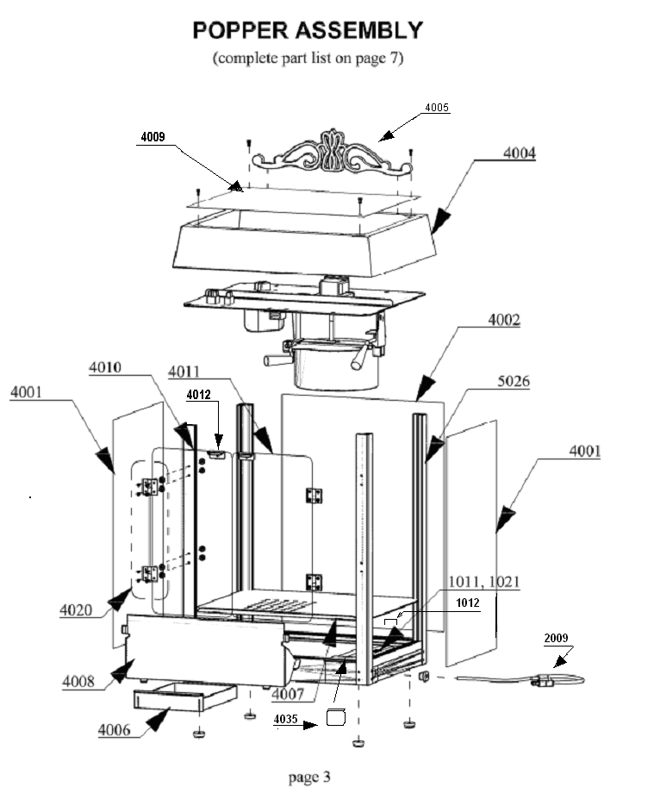4 OUNCE KETTLE ASSEMBLY

(complete parts list on page 7)

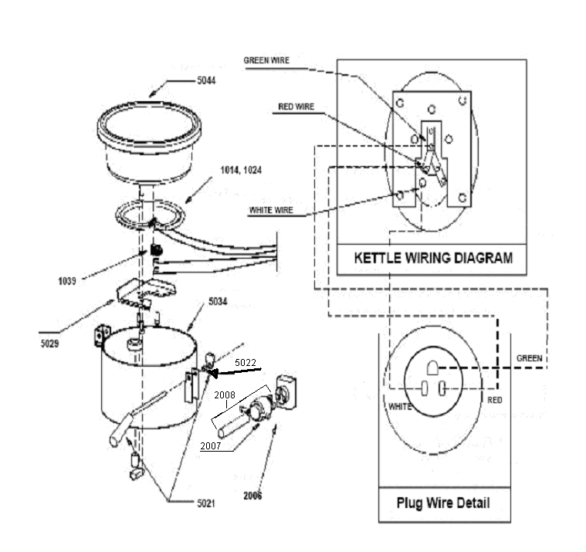

Page 5
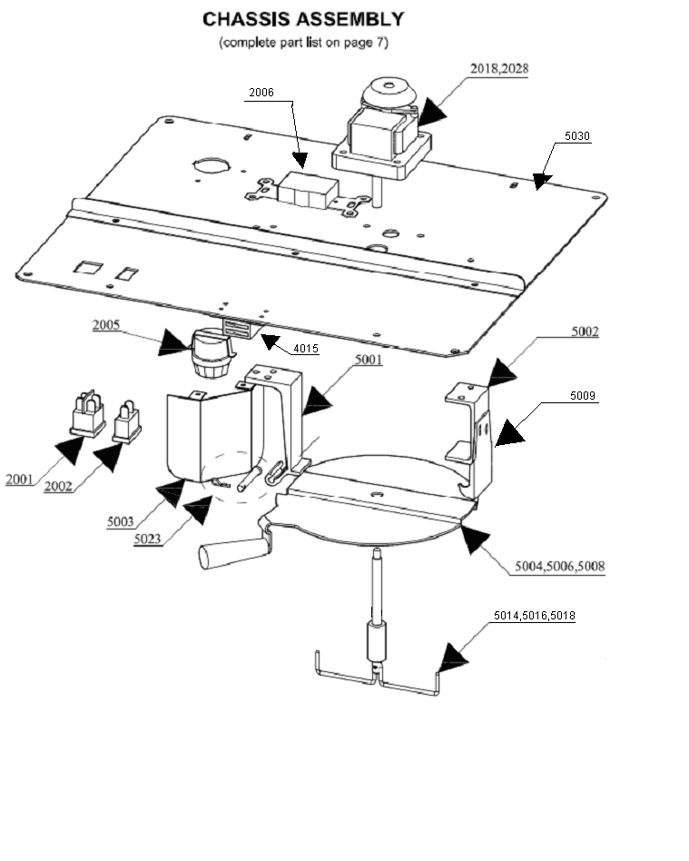

Page 6

PARTS LIST

P/N | Description |  | P/N | Description
0014 | 4 ounce kettle -120 volt |  | 4001 | Side glass
0024 | 4 ounce kettle -240 volt |  | 4002 | Front glass
0016 | 6 ounce kettle -120 volt |  | 4003 | Glass channel set
0026 | 6 ounce kettle -240 volt |  | 4004 | Black canopy top
0018 | 8 ounce kettle -120 volt |  | 4005 | Decorative cornice
0028 | 8 ounce kettle -240 volt |  | 4006 | Drawer
1001 | Popper Assembly |  | 4007 | Stainless product tray
1002 | Chassis Assembly |  | 4008 | Stainless drop door
1004 | Wiring Diagram |  | 4009 | Canopy Cover
1011 | 50w Warmer element -120 volt |  | 4010 | Left door
1012 | Warmer clamp |  | 4011 | Right door
1021 | 50w warmer element -240 volt |  | 4012 | Door handle
1014 | 800w kettle element -120 volt |  | 4015 | Door magnet
1024 | 800w kettle element -240 volt |  | 4020 | Door hinge set
1016 | 1000w kettle element -120 volt |  | 4033 | Base - complete
1026 | 1000w kettle element -240 volt |  | 4035 | Terminal box cover
1018 | 1250w kettle element -120 volt |  | 5001 | Left kettle hanger
1028 | 1250w kettle element -240 volt |  | 5002 | Right kettle hanger assembly
1039 | Thermostat |  | 5003 | Lamp Guard
2001 | Power switch |  | 5004 | 4 ounce kettle lid
2002 | Kettle switch |  | 5006 | 6 ounce kettle lid
2005 | Lamp socket |  | 5008 | 8 ounce kettle lid
2006 | Kettle socket |  | 5009 | Kettle latch
2007 | Kettle plug |  | 5014 | 4 ounce kettle stirrer
2008 | Kettle pigtail w/plug |  | 5016 | 6 ounce kettle stirrer
2009 | Power cord w/plug |  | 5018 | 8 ounce kettle stirrer
2018 | 120 volt (50/60 hz) gear motor |  | 5021 | Kettle handle complete
2028 | 240 volt (50/60 hz) gear motor |  | 5022 | Kettle handle spring
3002 | Cart handle |  | 5023 | Kettle hinge-pin/clip
3003 | Cart wheel |  | 5025 | Kettle lid magnet
3004 | Cart wheel clips |  | 5026 | Corner Post
3005 | Cart axle |  | 5029 | Kettle Element Clamp
3006 | Cart leg – short |  | 5030 | Chassis
3007 | Cart leg – long |  | 5034 | 4 oz. Kettle jacket
3008 | Cart shelf |  | 5036 | 6 oz. Kettle jacket
3009 | Cart body |  | 5038 | 8 oz. Kettle jacket
3010 | Cart hardware kit |  | 5044 | 4 oz. kettle inner
 |  |  | 5046 | 6 oz. kettle inner
 |  |  | 5048 | 8 oz. kettle inner

To Order Parts Contact:
Benchmark USA, Inc.
25-J Brookfield Oaks Dr.
Greenville, SC 29607 USA
Tel: 877-432-5500
Fax: 864-312-5505
Email: parts@benchmarkusainc.com
Page 7


Three Year Warranty

THE WARRANTY:
Benchmark USA warrants the original purchaser of new food equipment manufactured by Benchmark USA to be free from defects in material or workmanship from the date of the original purchase for a period of three years.

WHO IS COVERED BY THIS WARRANTY:
The original purchaser who has provided proper proof of the original retail purchase and all other requested information.

WHAT IS WARRANTIED:
The obligation of Benchmark USA under this warranty is limited to the replacement of any parts or components that in the opinion of Benchmark USA are defective, F.O.B. the factory, or at any other location that Benchmark USA may designate.

WHAT VOIDS THE WARRANTY:
1. Any piece of equipment that has been installed, operated or maintained inconsistently
with Benchmark USA operating instructions.
2. Any part or component that has been modified, changed or altered from its original
configuration.
3. Any electrical component that has been damaged due to submergence in any
liquid.
4. Any part or component that has been subject to abuse, misuse, neglect or
accidents.

EXTENT OF WARRANTY:
Any defective component, part or assembly returned to Benchmark USA will be replaced by Benchmark USA. Benchmark USA will not be responsible for any expenses incurred by the customer under the terms of this warranty, nor shall it be responsible for any damages either consequential, special, contingent, or otherwise; or expenses or injury arising directly or indirectly from the use of a Benchmark USA product. Any component, part or assembly returned to Benchmark USA must be returned at the customers expense along with proof of purchase. Benchmark USA reserves the right to determine whether the terms of this warranty have been properly complied with. In the event that the terms are not complied with, Benchmark USA shall be under no obligation to honor this warranty.

Benchmark USA Inc. ● 25-J Brookfield Oaks Dr. ● Greenville, SC 29607 ● T: 864-312-5500 ● F: 864-312-5505

